 | Modeling and Automation of Industrial Processes  MSc in Electrical and Computer Engineering  Scientific Area of Systems, Decision, and Control  2022 / 2023 |  | Group: ____  __-_____  __-_____  __-_____  __-_____

1st Lab. - PLC Digital Input and Output

The primary goal of this laboratory is to help participants become more familiar with Programmable Logic Controllers (PLCs) from Schneider, specifically the Premium series, including the TSX P57 1634M or 2634M models. These PLCs feature digital input and output modules with the following references: DEY16D2, DSY16T2, and DMY28FK. Key areas of focus: a) Utilizing the software development system, Unity Pro. b) Configuring the initial settings of the PLC. c) Referencing and utilizing user manuals provided by Schneider. d) Uploading and downloading programs to and from the PLC. e) Editing and debugging solutions. f) Establishing connections with external devices.

Part A - PLC Inputs and Outputs

Hardware to be used in the laboratory:
- PLC P57 with digital inputs and outputs made available through a 40-conductors flat cable
- One 40-conductors flat cable with one side free to strip and screw the wires to a terminal block
- One terminal block, 10-way screw down (to help connecting the flat cable wires to a breadboard)
- One breadboard, one 7-segments digit, one capacitor, two resistors and/or potentiometers

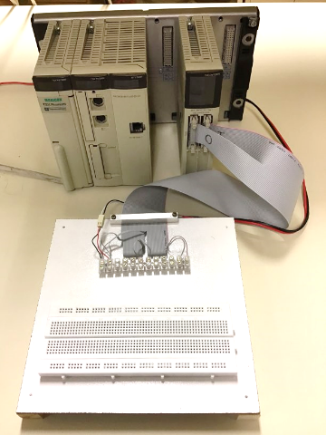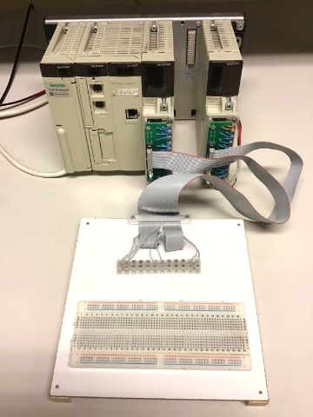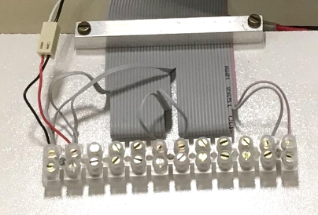
pin1
(wire1)
pin1
(wire1)
pin1
(wire1)
%i0.2.1
%i0.2.0
%q0.4.1
%q0.4.0
GND
Vcc
(a) Separate I/O modules | (b) One IO module | (c) 40-wire flat cable
Fig.1: Two hardware setups, same pinout on the flat cable. Setup (b) change names: %i0.2.0→%i0.3.0, %i0.2.1→%i0.3.1, %q0.4.0→%q0.3.16, %q0.4.1→%q0.3.17. The lab setups have more connections made to the flat cable, so that more outputs are ready to use.
A1. (+24V external power delivered to the input/output PLC modules) A 2-wires cable connects the external DC power supply directly to the input/output PLC modules or via the 40-wires flat cable (see Fig.1). Considering wire 1 of the 40-wires flat cable is colored red, indicate the wire numbers, within the 40-wires of the flat cable, that carry +24V or GND.

40-wires flat cable,  wire number 1-40 | GND  or +24V

A2. (Connect one digital output to a LED) Connect one digital output to one of the LEDs of the 7-segments digit. Use R=3.9KΩ between the PLC output and the LED (digit segment). Use the PLC graphical user interface (Unity Pro) to turn the LED ON or OFF.

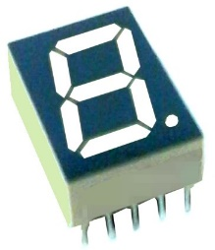

(a) SC52-11GWA | (b) All segments have a common ground | (c) Resistor to limit current | (d) Protect all LEDs for over-voltage at any * input

Fig.2: Digit formed by 7-segments and a decimal point (a). This is a common cathode digit meaning that all segments (LEDs) are connected to the ground (b), and therefore the inputs are driven by positive logic. Current has to be limited, i.e. +24V implies a 3.9KΩ before each segment (c). If by accident any input * receives +24V the respective LED over-heats, is convenient a common resistor for global protection (d).

A3. (Display sequence) Use seven PLC outputs to write one digit at each time in the 7-segments display. Make one ladder program that shows a sequence of digits 0, 1, 2, ..., 9, 0, 1, 2, ... standing about 1sec in each digit. Make a data log (plot) showing the time evolution of the counting, more precisely the time evolution of the states of the 7-segments.
Note: In Fig.2d all * inputs are separated from +24V by a resistor. However, by accident, one may do a short circuit that places +24V directly to a * input which will cause over-heat and failure. Despite losing luminosity, is recommended to use the protection shown in Fig.2d to the common pin for all LEDs. The pin marked nc can be left not connected.

A4. (Scan cycle period estimation) Consider the PLC is running your code, how long is the scan cycle period? Suggestion: Add Ladder instruction(s) to increment a counting in a memory variable at every scan cycle and use, for instance, the Windows Clock App to count 10 seconds. Annotate the counting of scan cycles that happened in 10 seconds.
Number of counted scan cycles in 10 seconds =
Average scan cycle time = [msec]
Indicate the setup, real or simulated PLC =
(write here the Ladder instructions used to estimate the scan cycle period; add space as needed)

Consult in the manuals how to use PLC system words to obtain (i) minimum and (ii) maximum scan-cycle times. Indicate those times in milliseconds. Suggestion: use one animation table to see the system words. Important: these system words are effective only when using the real PLC, they do not work in simulation.

Minimum scan cycle time msec (using system word) = [msec]
Maximum scan cycle time msec (using system word) = [msec]

Part B - Delaying OFF-to-ON using an RC Circuit

The objective of this section is to study the effect of capacities on transmitting digital information between PLC outputs and PLC inputs. Often, capacities of parasite nature appear in the cabling interconnecting PLCs and may introduce significant undesired communication delays.

Many PLC input and output modules have in account the possibility of significant capacities delaying communication. In many cases one observes design choices far different from conventional low impedance outputs and high impedance inputs. In case you want more information on input and output circuitry, it is suggested to see the input and output diagrams provided by the Unity Pro manuals.

Reference: You can see under the label HW IO Module, in the webpage of the course, the PDF file PLC_3_HW_IO_Discrete.pdf. In this PDF file you can find input and output hardware diagrams for the modules TSX DEY 16D2 and TSX DSY 16T2.

Work to do in the laboratory: Let R= 3.9KΩ and C= 1mF. Mount the resistor and the capacitor (RC) series circuit powered by a PLC digital output, see Fig.3. More in detail, connect one PLC output bit to the resistor and then connect the resistor to the positive terminal of the capacitor. This connection point, between the resistor and the capacitor, is observed by a PLC input. Important: it is an electrolytic capacitor, so polarity must be respected by putting the minus terminal connected to the ground (convention, the minus terminal is the shorter leg of the capacitor).

(a) Default test | (b) Tuning R= R₁+R₂
Fig.3: RC circuit powered by a PLC output and observed by a PLC input.

B1. (Output and input, time delay) Charge and discharge the capacitor using the Unity Pro, by turning ON or OFF one PLC output. Observe the time delay from turning OFF-to-ON the PLC output bit till that OFF-to-ON is observed in the PLC input bit. (Note: the delay is different for the ON-to-OFF transition.) Make a data log (plot) showing the OFF-to-ON delay. Make an estimate of this delay using an estimate of the scan cycle.

B2. (Reducing the delay) Let R=1KΩ and keep C=1mF. Use one potentiometer (trimmer) as a variable resistor in series with R and C to make the OFF-to-ON delay half the delay observed in B1. Make a data log (plot) showing the delay is smaller than the original delay.

B3. Comment on the statement: "Communication would be slower if there were a significant capacitance in the line and an infinite resistance at the PLC input". Suggestions: See the Unity Pro help (available in the Unity Pro menu) about the specific I/O modules. The help pages on the I/O modules detail precisely the circuits doing the input and output of signals. As a comparison, see non-industrial, Do It Yourself, hardware choices as the I/O on the Arduino
https://docs.arduino.cc/learn/microcontrollers/digital-pins .

