 | Industrial Processes Automation  MSc in Electrical and Computer Engineering  Scientific Area of Systems, Decision, and Control  Winter Semester 2013/2014 |  | Group: ____  __-_____  __-_____  __-_____  __-_____

2st Training Laboratory Work

Automation of an Access System

This preliminary work aims at providing an automation solution for the access to the underground transportation network, and its implementation on the PLCs available on the laboratory. Suppose that to implement the automatic access to the transportation network, e.g. the Metropolitano de Lisboa, the following subsystems are available (see also figure 1):
- Ticket Validation System characterized by two digital outputs and one digital input. The outputs inform about ticket detection and its validity. The input activates the scanning subsystem. Ticket input and scanning should only be activated when the door is closed (similar to ATMs which input cards only when they are ready to do so). Scanning produces the validity output and ejects the ticket. The validity output is available 1 second after the activation. The ticket detection and validity outputs remain active till the user takes out the ticket.
- Warning System, light and acoustic, commanded from one digital input.
- Automatic Door Opening System, commanded from one digital input. This system requires one second to open the door and one second to close it.

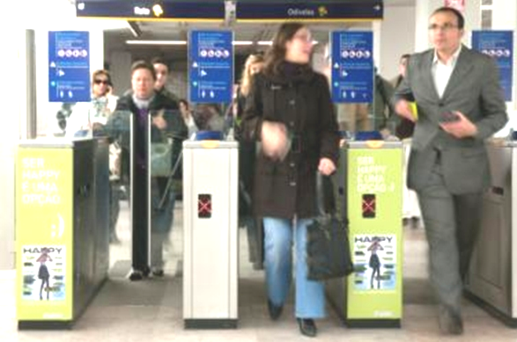
Figure 1: Main subsystems of an automated access system. List of inputs and outputs.

The functional specifications for the aforementioned system are detailed next:

Following the introduction of the ticket in the validation system, if it is valid, the door is activated to be fully open for 5 seconds, after ticket removal by the passenger. In the case that the ticket is not valid, the warning system is activated for 2 seconds, also upon the ticket removal. It must also be implemented a passenger counter and a defective ticket counter, that could be daily re-initialized.

1. Propose the architecture for the access system. Draw a diagram containing the subsystems and the PLC. Identify clearly the input and output connections to / from the PLC, to / from the subsystems.

2. Draw a time diagram of the input and output signals for a normal operation cycle involving a passenger entering a ticket, collecting it back, and consequently getting the door open. In case you need more signals or external subsystems, please list and describe them before the diagrams.
3. Choose the PLC inputs and outputs for the access system according to the PLC models available in the laboratory. List the inputs and outputs in the next table.

PLC Input | Identifier |  | PLC Output | Identifier

4. Enumerate for all timers that will use on the system, its function, and the counting base time

Timers | Function | Time Basis | Mode of Operation

5. Draw one or more ladder diagrams to solve the problem at hand. Separate the ticket scanning and the door/warning activation in two subroutines.

6. The PLC available in the laboratory performs vertical or horizontal scanning cycles? Suggest a small program to clarify this manufacturer option. Discuss the results obtained.

This training problem has no direct contribution to the final grade.

