 | Industrial Processes Automation  MSc in Electrical and Computer Engineering  Scientific Area of Systems, Decision, and Control  Winter Semester 2020/2021 |  | Group: ____  __-_____  __-_____  __-_____  __-_____

2nd Lab. - Handling Faults in Keyboard Reading

Part A - Petri Net

This laboratory assignment aims at studying Discrete Event Systems (DESs) in the aspects of modeling, analysis of properties and synthesis. Synthesis will be based on a recent methodology in the framework of supervised control. This assignment further develops the previous assignment in the keyboard reading component by introducing fault handling mechanisms.

Schneider's Unity Pro will be used to validate the proposed methodologies. The tools mostly used in this work run in MATLAB, namely one supervisor design toolbox and one Petri Net editor. Using the login information indicated in the course webpage, see in the course SVN:
- The graphical freeware editor "PIPE2" which allows creating Petri Net models to import with the MATLAB toolbox "TPN5" (use the version available in the SVN)
- MATLAB functions simulating Petri nets, in particular the "5 Philosophers" demo and a template for simulating the keyboard "lab2_sim_kb_v6.zip".

Preliminary experiments:


A1: [PN to PLC] See in the course SVN the demonstration of the Petri nets to PLC code converter, named tst3_blink_on_off.m . (i) Draw the graph of the Petri net considered in the demonstration. (ii) Run the demo on Unity Pro (simulator) by inserting the structured text output of tst3_blink_on_off.m into a Unity Pro project (see Annex A1). Note that some testing can be done with myterminal5. (iii) Show a data log of the inputs and/or outputs.


A2: [PN simulation] See in the course SVN the "5 philosophers' dinner" simulation named pdinner_tst.m (see also Annex A2). (i) Show that in the simulation one philosopher has a request to eat not served. (ii) Propose one modification to pdinner_IO.m so that another philosopher gets a request to eat not served.

DES modeling:

Using as a base guideline the work done in the first laboratory assignment, it is now desired to model the process of reading one keyboard key as a DES. More in detail, is required to develop a Petri Net that describes the events and the state evolution of the key reading system. In addition to the formal definition of the Petri Net, it is desired also to obtain the corresponding incidence matrix.
Note: In order to obtain a Petri Net as simple as possible, with less than 25 places, the rejection of multiple keys (first laboratory, part B) should not be included now. The rejection of multiple keys will be subject of formal analysis in part C of this assignment.


A3: Write the list of events of the DES you are proposing. (Fill the next table, adding as many lines as needed).

Event Identifier | Description


A4: Write the list of conditions of the DES you are proposing. (Fill the next table, adding as many lines as needed).

Condition Identifier | Description


A5: Write the table of pre and post conditions for each of the events. (Fill the next table, adding as many lines as needed).

Event | Pre-Conditions | Post-Conditions


A6: Characterization of the Petri net. (i) Draw the graph of the Petri Net. (ii) Comment about temporizations used, or not used, in the proposed DES. (iii) Obtain the incidence matrix, D=D⁺-D⁻, describing the proposed Petri Net.


A7: [PN simulation] Simulate the Petri net you proposed in the previous questions. Comment whether your simulation software implies, or does not imply, privileged places or transitions while receiving random inputs. As helping references see question B1 and the template for simulating the keyboard "lab2_sim_kb_v6.zip" (to be completed by the groups).

Annex A1 - Convert a Petri net to a PLC program

In this annex is detailed the testing of a converter of a Petri net to a PLC program. The converter is written and runs in MATLAB. The converter and the demonstration example are included in the SVN of the course.

Please find in your local installation the folder ./lab2_intro/ and run tst3_blink_on_off.m . Note that the compiler is in the course SVN, folder ../pn_to_plc_compiler/ which is accessible when you do login_api.

The command plc_z_code_helper('config', ...) included in tst3_blink_on_off.m, already defines the PLC modules / memory configuration. In case you remove that command, the configuration needs to be defined once per MATLAB session. Three configurations are possible (see figure A1.1):
- s2_DEY16D2_s4_DSY16T2 means the PLC has two modules, at slots two and four, and the modules are named DEY16D2 and DSY16T2.
- s3_DMY28FK means the PLC has only the module DMY28FK mounted at slot three.
- m0-9_m10-19 means the input/output is based on memories %m0 till %m19.

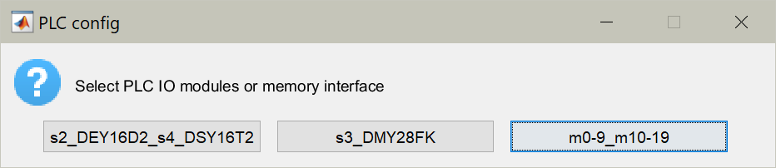
Figure A1.1: Selection of the hardware configuration, input/output modules or memory interface.

After running the demonstration, you obtain file tst3_mk_program_res.txt containing structured text code that you can copy into a Unity project. Within the Unity project you need to declare some additional variables like the timer names, timing values and flags. Please see more details in the text file _readme.txt .

To have more information on the Petri net to PLC code converter see:
http://users.isr.ist.utl.pt/~jag/course_utils/pn_to_plc/pn_to_plc.html

Annex A2 - Philosophers Dinner Petri Net Simulation

Please find in the SVN of the course the "5 philosophers dinner" simulation folder. Locate and run in MATLAB the file pdinner_tst.m. Note that you need also the rdp.m function found in the tpn5 toolbox which is also in the SVN - see the SVN root file _readme.txt for details.

The pdinner_tst.m demonstration script loads a Petri net model shown in figure A2.1 and built using PMEDIT. The Petri net model is read using the referred rdp.m function.

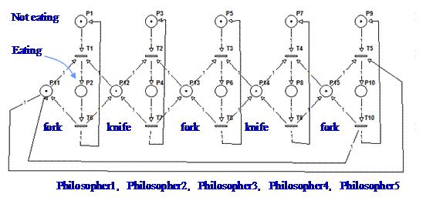
Figure A2.1: Petri net model representing the 5 philosophers dinner problem.

The default simulation has the transitions scheduled, driven by a timetable. To run a simulation where the transitions are driven randomly, you can edit the file PN_tfire.m and replace the line:
qk= pdinner_IO(act, t);

by the line:
qk= round(rand(1,5)); qk= [qk not(qk)];

Note that only transitions 1 till 5 are computed randomly. Transitions 6 till 10 are defined simply as the negation of the transitions 1 till 5.

To have more information on the Petri net simulator and the specific simulation of the "5 philosophers dinner" see:
http://users.isr.ist.utl.pt/~jag/course_utils/pn_sim/PN_sim.html

Original guide by Prof. Paulo J. Oliveira. Revised by Prof. José Gaspar (2021).

