 | Industrial Processes Automation  MSc in Electrical and Computer Engineering  Scientific Area of Systems, Decision, and Control  Spring Semester 2020/2021 |  | Group: ____  __-_____  __-_____  __-_____  __-_____  __-_____
2st Training Laboratory Work

Automation of an Access System

Despite not being graded, it is important to fill this guide. The filling of this guide provides self-assessment of the acquaintance with subsystems integration.

This preliminary work aims at providing an automation solution for the access to the underground transportation network, and its implementation on the PLCs available in the laboratory.

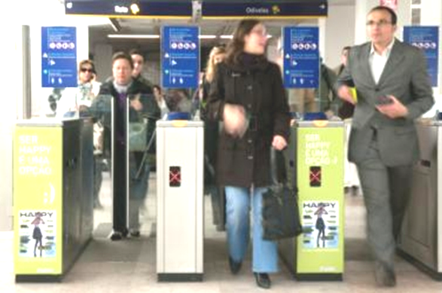
Figure 1: Main subsystems of an automated access system. List of inputs and outputs.

Suppose that to implement the automatic access to the transportation network, e.g. the Metro of Lisbon, the following subsystems are available (see also figure 1):

- Device 1, Programmable Logic Controller (PLC), micro PLC with 8 digital inputs and 8 digital outputs

- Device 2, Motor to Open / Close Door, is a subsystem commanded by two digital outputs of the PLC. This motor requires one second to open the door and one second to close it.

- Device 3, Warning Lamp and Bell, light and acoustic subsystem, is commanded by one digital output of the PLC.

- Device 4, Ticket Reader is a subsystem characterized by two digital outputs and two digital inputs (see Annex A). Two PLC inputs are driven by the Ticket Reader outputs to inform that a ticket has been detected in the entry point of the slot to insert the ticket and, after scanning, whether the ticket is valid or invalid. The enable_TR PLC output enables the Ticket Reader. A rising edge on enable_TR causes the Ticket Reader to unblock the entry point of the slot to insert the ticket. The PLC output ticket_scan commands the Ticket Reader to actually grab the ticket and verify whether it is valid or not. Ticket grab and scan should only be commanded when the door is closed (similar to ATMs in which cards are accepted, carried inside, only when the ATMs are ready to do so). Scanning produces the validity output and ejects the ticket. The validity output is available 1 second after the activation. The ticket detection and validity outputs remain active till the user takes out the ticket.

The functional specifications for the aforementioned system are detailed next:

Following the introduction of the ticket in the validation system, if it is valid, the door is actuated to be fully open for 5 seconds, after ticket removal by the passenger. In the case that the ticket is not valid, the warning system is activated for 2 seconds, also upon the ticket removal. It must also be implemented a passenger counter and a defective ticket counter, that could be daily re-initialized.


Q1. (Report) Propose the hardware architecture for the access system. Draw a diagram containing the PLC (Device 1) and the subsystems (Devices 2, 3 and 4). Let one switch, named turn_ON_AS represent the turning ON of the complete access system. Identify clearly the input and output connections to / from the PLC and to / from the subsystems.

---- From here till the end of the work, consider just Device 4, NOT the full system ----


Q2. (Report) Assume that Device 4 is based on a card reader controlled by a PLC. More precisely, recall that the full system is integrated by a PLC (Device 1) while here we are proposing a second PLC (PLC2) to implement Device 4. The card reader is not available in the laboratory. Implementation and testing of Device 4 will be based on switches:
- Let enable_TR be represented by one ON/OFF switch. Let ticket_detected, ticket_is_valid and ticket_scan be represented by three push buttons (keyboard keys) 1, 4 and 7.
- Show the main output of the Ticket Reader, ticket_is_valid, on two LEDs, one indicating the ticket is valid and the other one indicating the ticket is invalid.
In your solution, please consider the response time indicated beforehand for Device 4. Draw one or more ladder diagrams to solve the problem at hand. Refer in your answer how to use named variables instead of physical variables in Unity Pro.


Q3. (Report) Choose the PLC2 inputs and outputs to simulate Device 4 according to the PLC models available in the laboratory. Use the terminal already attached to the PLC, which contains ON/OFF switches, contains one keyboard (use keys 1, 4 and 7) and three LEDs. List the inputs and outputs in the next table. As it is not possible to use the real PLCs and terminal, consider using Matlab myterminal5 and its interface based on memory bits (%m0 .. %m19).

PLC2 input address (PLC memory bit) | Input name |  | PLC2 output address (PLC memory bit) | Output name

Note: In order to use keys 1, 4 and 7 of the Matlab myterminal5 interface, the %m14 must be set ON.


Q4. (Experiment, test Device 4 where the card reader is simulated by switches) Run in the PLC the program developed in Q2 to implement Device 4 and demonstrate the following use cases: (i) a user tries to introduce a ticket when the Ticket Reader is not enabled and therefore nothing happens, (ii) a user introduces a ticket with the Ticket Reader enabled but the ticket is invalid, (iii) is as the previous case, but now the ticket is valid. Comment on the success of the experiments.


Q5. (Report) Discuss how the simulation of Device 4 could be integrated in an implementation and test of a full system.

Annex A: Ticket Reader (TR)

Figure A1 illustrates the use of a ticket reader and details some of its internal working. The objective of blocking the entry of tickets (cards) is related with a common requirement that the door is permanently closed e.g. for repair or maintenance.

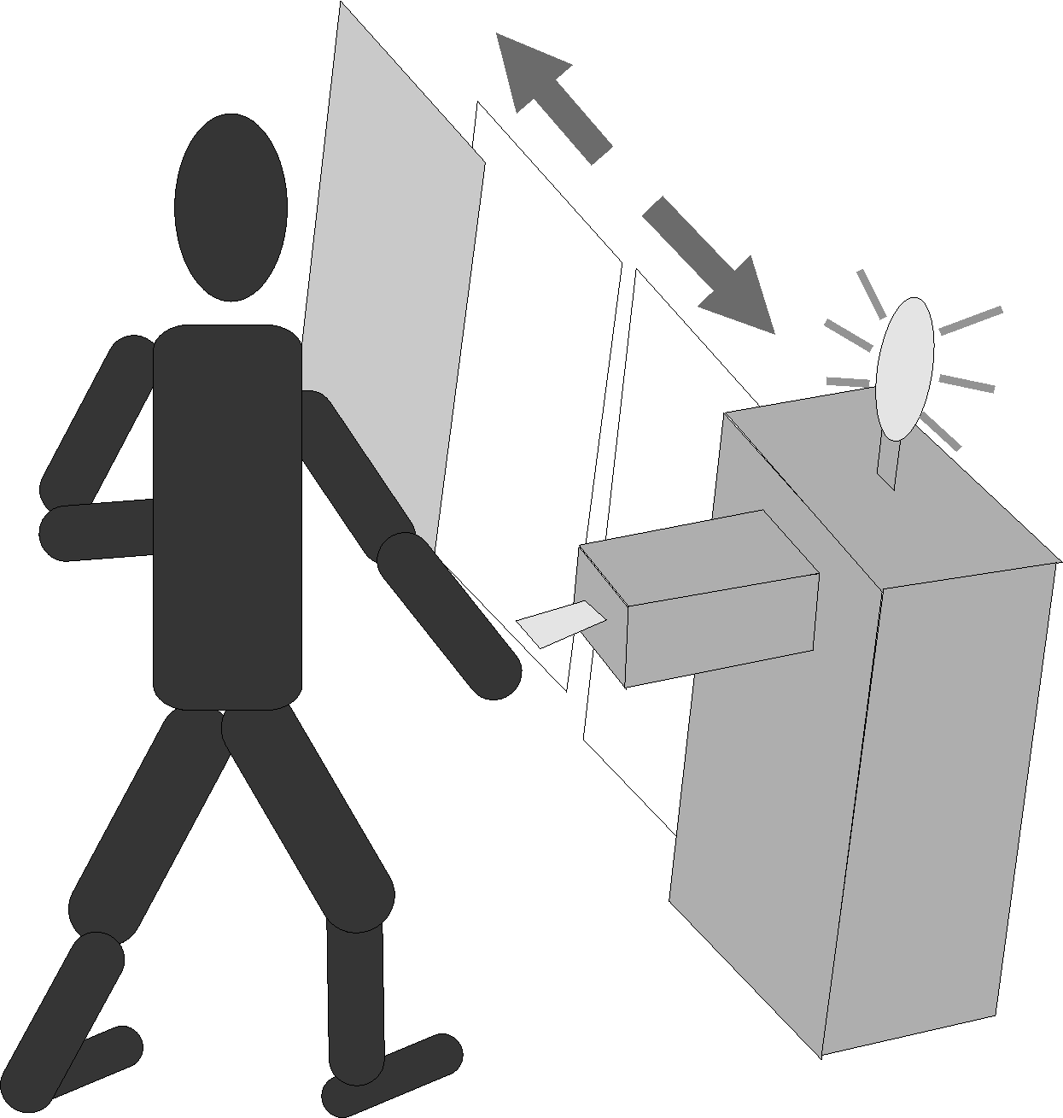 | 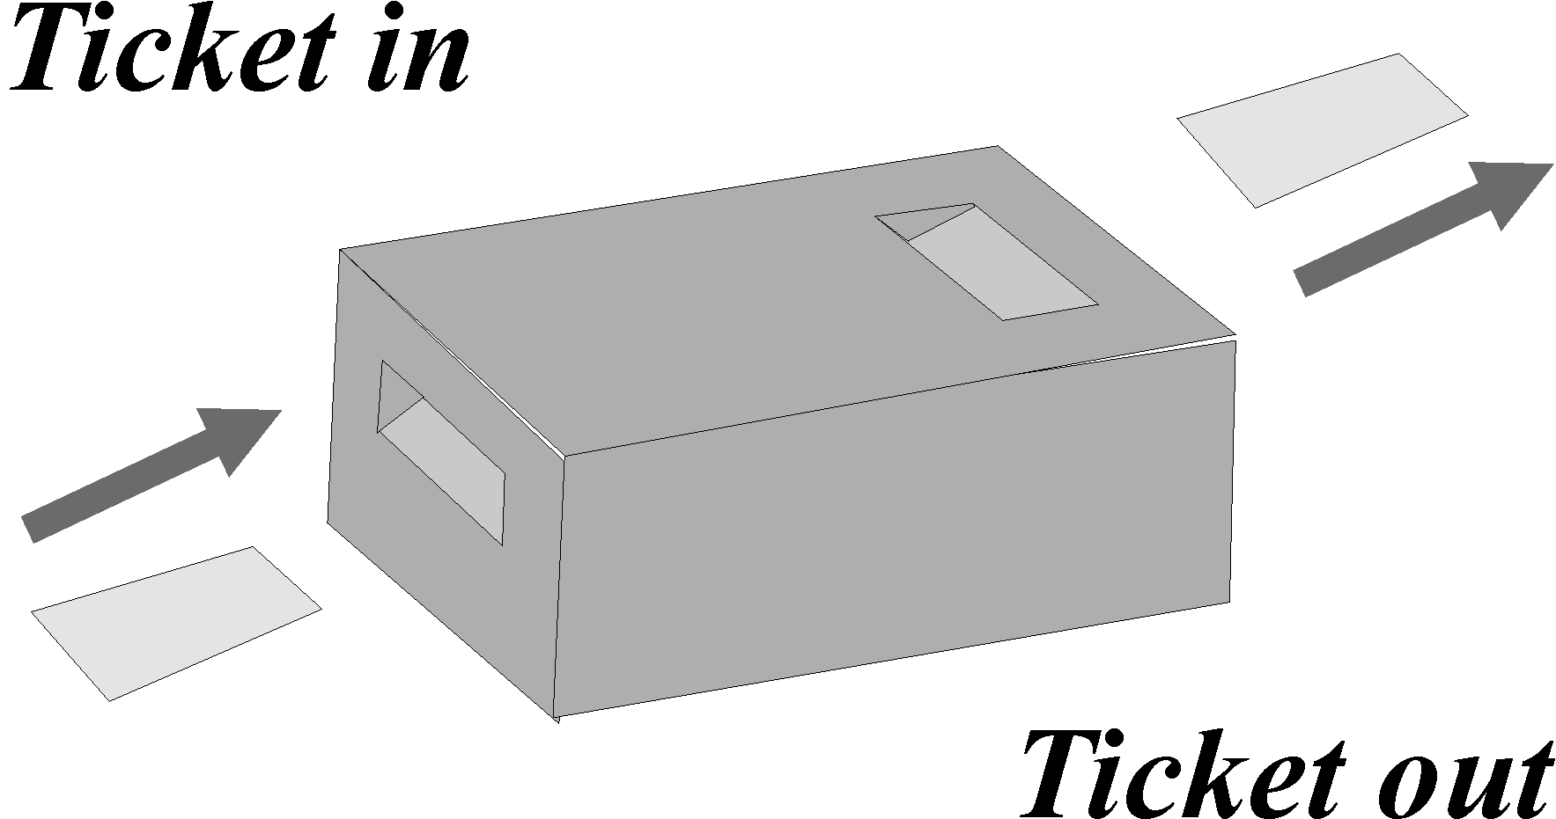
(a) Door open given valid ticket | (b) Ticket insert and take out points.
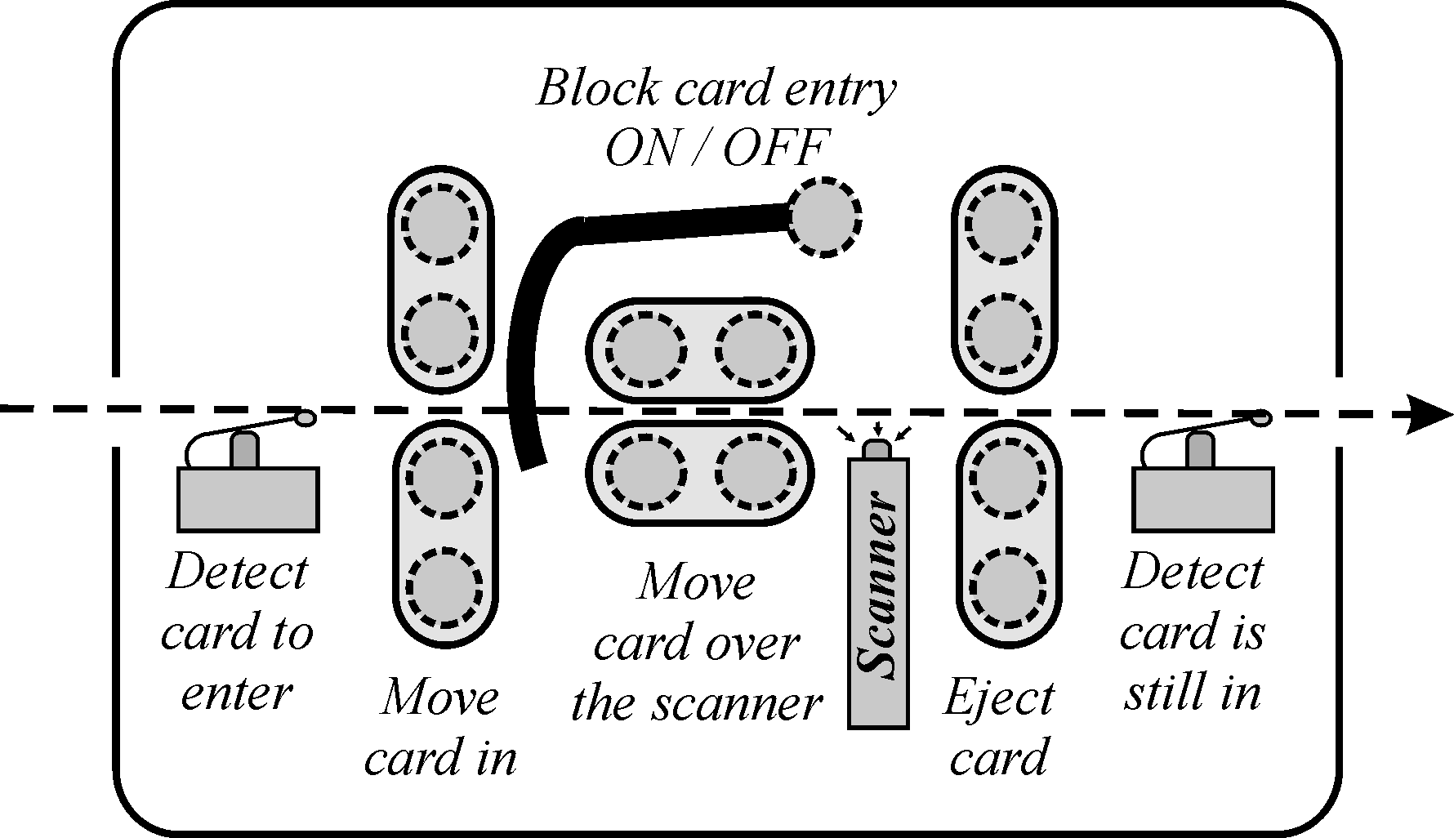
(c) Internal motion and scanning of the ticket (card).
Figure A1: Ticket reader system serving in an automatic door opening system (a). Tickets are scanned inside a box to avoid exposing the scanner (b). Ticket scanning can be physically closed, and scanning speed can be controlled to match the scanner requirements (c).

The proper optical or magnetic reading of the ticket implies that it is moved at a constant speed over the reading head of the scanner. A motorized transport conveyer is used to avoid too fast or too slow scanning of the ticket.
The detection that a ticket is still inside the ticket reader is related with the requirement that the ticket continues to be carried by its owner. More in detail, the door will not open until the ticket is taken out and therefore the ticket is not forgotten in the ticket reader.

This training problem has no direct contribution to the final grade.

