 | Industrial Processes Automation  MSc in Electrical and Computer Engineering  Scientific Area of Systems, Decision, and Control  Spring Semester 2020/2021 |  | Group: ____  __-_____  __-_____  __-_____  __-_____  __/__/2021

1st Training Laboratory Work

Latch Circuit

The main objective of the 1st training laboratory is to allow the participants to get familiar with the Programmable Logic Controllers (PLCs) Schneider Premium P57 available in the laboratory, model Premium TSX P57 1634M or TSX P57 2634M, see Fig1(a) or (b). In particular are relevant: a) Using the software development system, b) Setting the PLC initial configuration, c) Using the user manuals from Schneider, d) Uploading / downloading programs to/from the PLC, e) Editing and debugging solutions.

Important: while in effect the current suspension of presence classes, set to protect public health, this laboratory assignment will be based on simulated-hardware, where digital inputs and outputs are PLC memory locations, which are read and written by the fieldbus Modbus, see Fig1(c).

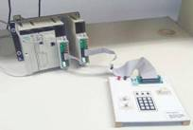  (a) Setup with one input and one output modules  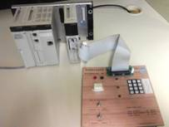  (b) Setup based on a single input and output module | 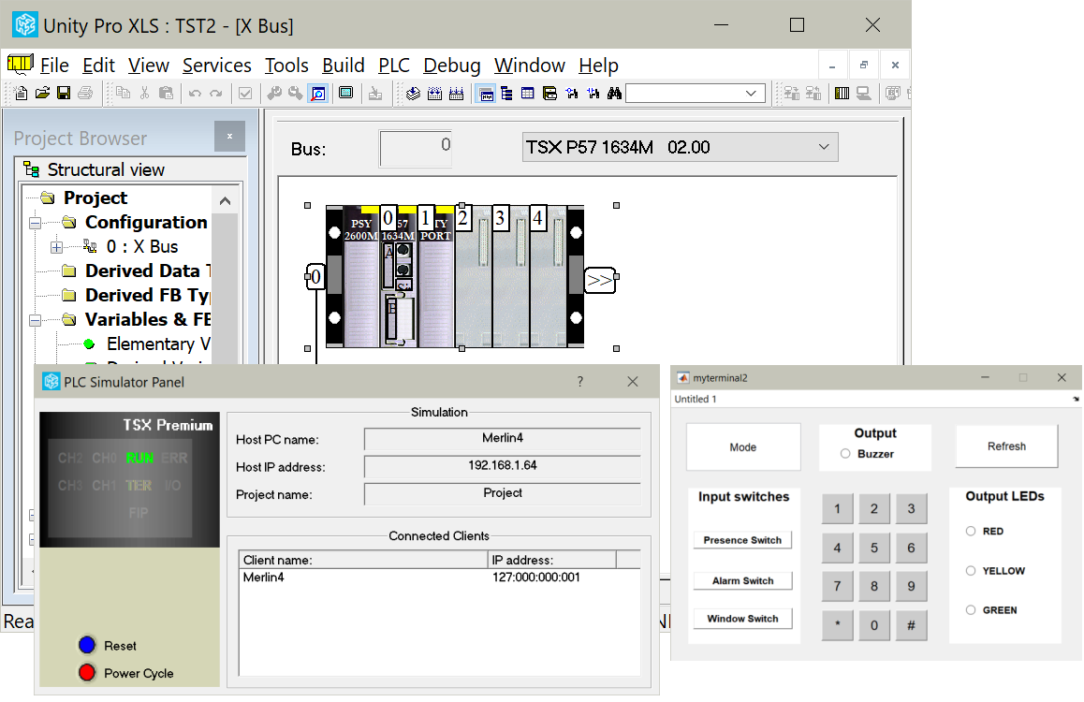  (c) Simulated-hardware setup. The input and output are mapped on the PLC memory.

Fig.1: PLC and terminal setups, real (a, b) and simulated (c). The virtual terminal, shown in (c), formed by switches and LEDs, is simulated in Matlab, and connects to the PLC simulator based on Modbus.

Alternatively, to avoid using Matlab, this training laboratory can be based on using an animation table (see Fig.2). One may enable forcing the values of variables by clicking the "Force" button, and then may force to 1 or 0 the values of input1 and input2.

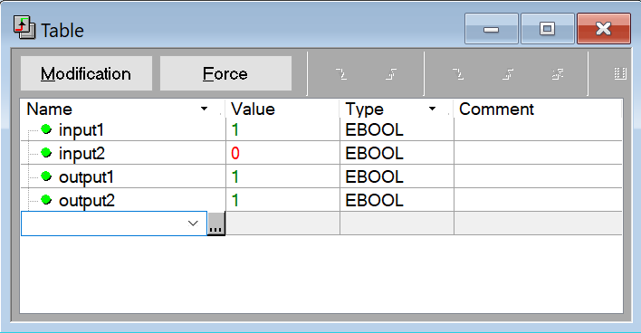
Fig.2: Animation table showing four variables, two inputs and two outputs. Clicking the Force button allows changing the values of the inputs.

In this training work are implemented sequential logic circuits using the PLCs available in the laboratory. More in detail, one latch is implemented based in two alternative (combinatorial) logic functions.

Q1. Draw a Ladder diagram implementing the logic circuit described by
output1= input1 OR ( NOT( input2 ) AND output1 )
where input1 and input2 are PLC inputs and output1 is a PLC output.

Q2. Identify the inputs and outputs that will be used in the PLC. In other words, choose two hardware inputs and one output to implement input1, input2 and ouput1. Important: since there is not possible to use the real PLCs, memory addresses have to be used for inputs and outputs. Note: Search in the Unity Pro manuals how to name the hardware inputs (PLC memories) to the strings input1, and input2, and name the hardware output (PLC memory) as output1.

Hardware identifier / name
(PLC memory bit)
input1
input2
ouput1

Q3. Download the program to the PLC and execute the program in the PLC. Test your program by setting input values and watching the output. Note: the programming user interface allows forcing (setting) input values; the real input voltages are ignored when the input bits are set to forced.

Q4. Draw a Ladder diagram implementing an alternative latch circuit
output2= (input1 OR output2) AND NOT(input2)
Test your program using the same input values chosen in the previous question.

Q5. Show that the two latch implementations are similar but not exactly equivalent. Suggestion: write a truth table computing the outputs output1 and output2 from the inputs input1 and input2, and the previous state of the output output1_prev or output2_prev.

This training problem has no direct contribution to the final grade.

