 | Industrial Processes Automation  MSc in Electrical and Computer Engineering  Scientific Area of Systems, Decision, and Control  Winter Semester 2017/2018 |  | Group: ____  __-_____  __-_____  __-_____  __-_____  __/__/2017

2st Training Laboratory Work

Automation of an Access System

Please print and bring this guide to the laboratory. Despite not being graded, it is important to fill and deliver it in the end of the class so that it provides some feedback on the acquaintance with subsystems integration.

This preliminary work aims at providing an automation solution for the access to the underground transportation network, and its implementation on the PLCs available on the laboratory.

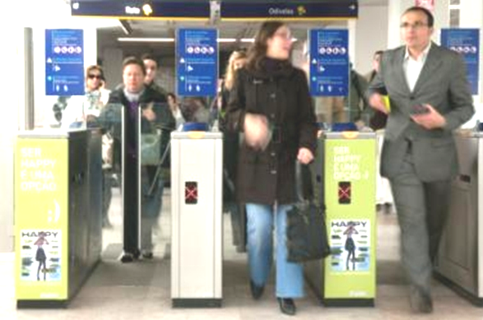
Figure 1: Main subsystems of an automated access system. List of inputs and outputs.

Suppose that to implement the automatic access to the transportation network, e.g. the Metro of Lisbon, the following subsystems are available (see also figure 1):

- Device 1, Programmable Logic Controller (PLC), micro PLC with 8 digital inputs and 8 digital outputs

- Device 2, Motor to Open / Close Door, is a subsystem commanded by two digital outputs of the PLC. This motor requires one second to open the door and one second to close it.

- Device 3, Warning Lamp and Bell, light and acoustic subsystem, is commanded by one digital output of the PLC.

- Device 4, Ticket Reader is a subsystem characterized by two digital outputs and two digital inputs. Two PLC inputs are driven by the Ticket Reader outputs to inform that a ticket has been detected in the entry point of the slot to insert the ticket and, after scanning, whether the ticket is valid or invalid. The enable_TR PLC output enables the Ticket Reader. A rising edge on enable_TR causes the Ticket Reader to unblock the entry point of the slot to insert the ticket. The PLC output ticket_scan commands the Ticket Reader to actually grab the ticket and verify whether it is valid or not. Ticket grab and scan should only be commanded when the door is closed (similar to ATMs in which cards are accepted, carried inside, only when the ATMs are ready to do so). Scanning produces the validity output and ejects the ticket. The validity output is available 1 second after the activation. The ticket detection and validity outputs remain active till the user takes out the ticket.

The functional specifications for the aforementioned system are detailed next:

Following the introduction of the ticket in the validation system, if it is valid, the door is actuated to be fully open for 5 seconds, after ticket removal by the passenger. In the case that the ticket is not valid, the warning system is activated for 2 seconds, also upon the ticket removal. It must also be implemented a passenger counter and a defective ticket counter, that could be daily re-initialized.

Q1. (Report in paper) Propose the hardware architecture for the access system. Draw a diagram containing the PLC (Device 1) and the subsystems (devices 2 till 4). Add two extra switches, named turn_ON and turn_OFF, to turn ON or OFF the complete system. Identify clearly the input and output connections to / from the PLC and to / from the subsystems.

---- From here till the end of the work, it is considered only Device 4, NOT the full system ----

Q2. (Report in paper) Assume that Device 4 is also based on a PLC. More precisely, recall that the full system is integrated by a PLC (Device 1) while here we are proposing a second PLC (PLC2) to implement
Device 4. The hardware to read cards is not available in the laboratory. Implementation and testing will be based on switches:
- Pressure switch 1 generates the PLC2 input signal enable_TR.
- Pressure switch 2 generates (simulates) the PLC2 input signal ticket_detected.
- On/Off switch 1 is one input of PLC2 simulating the ticket is valid (On means valid, Off means invalid)
- Pressure switch 3 generates the PLC2 input signal ticket_scan.
The outputs of the Ticket Reader are shown on two LEDs, one indicating the ticket is valid and the other one indicating the ticket is invalid. In your solution, please consider the response time indicated beforehand for Device 4. Draw one or more ladder diagrams to solve the problem at hand. Refer in your answer how to use named variables instead of physical variables in Unity Pro.

Q3. (Report in paper) Choose the PLC2 inputs and outputs to simulate Device 4 according to the PLC models available in the laboratory. Use the terminal already attached to the PLC, which contains On/Off switches, contains one keyboard (use keys 1, 4 and 7 as pressure switches) and three LEDs. List the inputs and outputs in the next table.

PLC Input | Identifier |  | PLC Output | Identifier

Q4. (PLC2 experiment, test of Device 4) Run in the PLC the program developed in Q2 to implement
Device 4 and demonstrate the following use cases: (i) a user tries to introduce a ticket when the Ticket Reader in not enabled and therefore nothing happens, (ii) a user introduces a ticket with the Ticket Reader enabled but the ticket is invalid, (iii) is as the previous case, but now the ticket is valid. Comment on the success of the experiments.

Q5. (Report in paper) Discuss how the simulation of Device 4 could be integrated in an implementation and test of a full system.

This training problem has no direct contribution to the final grade.

