 | Industrial Processes Automation  MSc in Electrical and Computer Engineering  Scientific Area of Systems, Decision, and Control  Winter Semester 2015/2016 |  | Group: ____  __-_____  __-_____  __-_____  __-_____  __/__/2015

2st Training Laboratory Work

Automation of an Access System

This preliminary work aims at providing an automation solution for the access to the underground transportation network, and its implementation on the PLCs available on the laboratory.

Please print and bring this guide to the laboratory. Despite not being graded, it is important to fill and deliver it in the end of the class so that it provides some feedback on the acquaintance with subsystems integration.

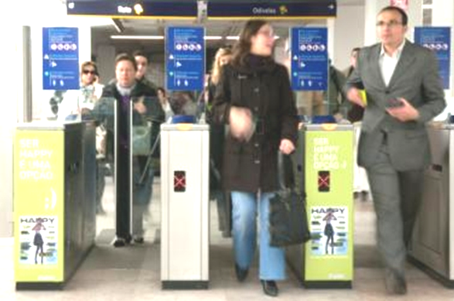
Figure 1: Main subsystems of an automated access system. List of inputs and outputs.

Suppose that to implement the automatic access to the transportation network, e.g. the Metropolitano de Lisboa, the following subsystems are available (see also figure 1):

- Programmable Logic Controller (PLC), micro PLC with 8 digital inputs and 8 digital outputs
- Warning Lamp and Bell, light and acoustic subsystem, is commanded by one digital output of the PLC.
- Motor to Open / Close Door, is a subsystem commanded by two digital outputs of the PLC. This motor requires one second to open the door and one second to close it.

- Ticket Reader is a subsystem characterized by two digital outputs and two digital inputs. Two PLC inputs are driven by the Ticket Reader to inform that a ticket has been detected in the entry point of the slot to insert the ticket and, after scanning, whether the ticket is valid or invalid. The turn_ON PLC output, commanding the Ticket Reader, allows unblocking the entry point of the slot to insert the ticket. The PLC output ticket_scan commands the Ticket Reader to actually grab the ticket and verify whether it is valid or not. Ticket grab and scan should only be commanded when the door is closed (similar to ATMs in which cards are accepted, carried inside, only when the ATMs are ready to do so). Scanning produces the validity output and ejects the ticket. The validity output is available 1 second after the activation. The ticket detection and validity outputs remain active till the user takes out the ticket.

The functional specifications for the aforementioned system are detailed next:

Following the introduction of the ticket in the validation system, if it is valid, the door is actuated to be fully open for 5 seconds, after ticket removal by the passenger. In the case that the ticket is not valid, the warning system is activated for 2 seconds, also upon the ticket removal. It must also be implemented a passenger counter and a defective ticket counter, that could be daily re-initialized.

1. Propose the hardware architecture for the access system. Draw a diagram containing the subsystems and the PLC. Identify clearly the input and output connections to / from the PLC, to / from the subsystems.

2. Draw a time diagram of the input and output signals for a normal operation cycle involving a passenger entering a ticket, collecting it back, and consequently getting the door open. In case you need more signals or external subsystems, please list and describe them before the diagrams.

3. Choose the PLC inputs and outputs for the access system according to the PLC models available in the laboratory. List the inputs and outputs in the next table.

PLC Input | Identifier |  | PLC Output | Identifier

4. Enumerate for all timers that will use on the system, its function, and the counting base time

Timers | Function | Time Basis | Mode of Operation

5. Draw one or more ladder diagrams to solve the problem at hand. Separate the ticket scanning and the door/warning activation in two subroutines.

This training problem has no direct contribution to the final grade.

