 | Industrial Processes Automation  MSc in Electrical and Computer Engineering  Scientific Area of Systems, Decision, and Control  Winter Semester 2012/2013

1st Laboratory Assignment

Alarm System for Intrusion Detection

This work aims the implementation of an intrusion detection alarm system, in a restricted space as a retail store having one single small room. The intrusion will be detected resorting to an infrared sensor, installed in such a way that points towards the main entrance of the space to be protected. A switch is also installed on a window of the aforementioned space.
The automation system that constitutes the alarm is to be implemented in the Schneider PLCs available on the laboratory, model Premium TSX P57 1634M or TSX P57 2634M. This document is composed by two sections: the first describes the guidelines for the first session on the lab and the second (see annex) describes the functional specifications of all the work that will be developed in the next weeks.

Part A - System Components

General characteristics of the alarm:

The Alarm has three main modes of operation, OFF, Presence Detector and Active. The three modes are selected by a three positions switch. The general characteristics of the three modes of operation are detailed next:
(Mode 1) OFF – this mode deactivates the alarm completely.
(Mode 2) PRESENCE DETECTOR – the infrared sensor is used to detect movement in the room, and signalize it using both a lamp (LED) and the buzzer on the panel. The lamp should be on for 5 seconds, upon the detection of each person, and an acoustic signal with the duration of 1 second should be emitted.
(Mode 3) ACTIVE – in this mode the alarm is to be used.

Detailed specifications for mode 3, ACTIVE, are the following:
a) When requested for activation, a period of 30 seconds of inactivity is set to allow the user to abandon the space, and afterwards remains permanently activated.
b) Upon intrusion detection, by the infrared sensor or the window switch, the alarm evolves to the warning phase.
c) The alarm lights a warning on the panel and after 5 seconds the buzzer must be activated. The warning must be a periodic signal with 1 second on and 2 seconds off.
d) The alarm can be deactivated pressing the # key on the command panel.

Implementation details

In order to implement the general characteristics of the alarm in a clear manner, it is important to separate into one sub-routine the mode 2, Presence Detector, and to another sub-routine the mode 3, Active. The indications of a detected presence and of an intrusion should also be implemented into one separate sub-routine. More sub-routines can be added in case they help making the code more clear.
In order to help the readability of the proposed solution, the identifiers used in the PLC program must have readable names. For example it is more readable using "I_switch1_pos1" than using "%I0.2.0". The following naming convention is therefore suggested: I_xyz for inputs, O_xyz for outputs, M_xyz for memory variables, TM_xyz for timers, SR_xyz for sub-routines, etc, where xyz denotes meaningful names.
Note: in this part of the work the infrared sensor is replaced by the two positions switch.

Report questions

Q1. Identify the inputs and outputs of the intrusion detection alarm console. To achieve that purpose, identify all the inputs and outputs.
Input  (chosen variable name) | PLC Identifier  (physical address) |  | Output  (chosen variable name) | PLC Identifier  (physical address)

Q2. (Hardware test program) Design and test a ladder program that verifies the proper functioning of the output devices available in the alarm console. More precisely, the program must beep the buzzer and turn the three lamps (LEDs), one after the other, 0.5 seconds each. In addition, discuss how can be implemented a test of the input devices available in the console. (Add an extra sheet of paper to answer this question).

Q3. Consider the alarm application in this and the next questions. List and describe the timers that will be used, their function, and the delay times to be selected for each one.

Timer name and/or physical address | Operation mode | Time Delay | Short description of the  usage of the timer

Q4. List the sub-routines to implement in the alarm application. In particular indicate the routine names and list variables shared with other routines or sub-routines. Classify the listed variables as "input", "output" or "input and output".

Q5. Design one or more ladder sections to solve the aforementioned automation problem. (Add an extra sheet of paper to answer this question).

Q6. Upload the program to the PLC and execute it. Comment how it runs.

Annex - Functional Specifications of the Alarm

The Alarm has three main modes of operation, OFF, Presence Detector and Active. The three modes are selected by a three positions switch. The three modes operate as detailed next:
(Mode 1) OFF – this mode deactivates the alarm completely.
(Mode 2) PRESENCE DETECTOR – the infrared sensor is used to detect the movement on the room/space, that be signalized resorting both to a lamp and to the buzzer on the panel. The lamp should be on for 5 seconds, upon the detection of each person, and an acoustic signal with the duration of 1 second should be emitted.
(Mode 3) ACTIVE – in this mode the alarm is to be used.

Detailed specifications for mode 3, ACTIVE, are the following:
a) When requested for activation, a period of 30 seconds of inactivity is set to allow the user to abandon the space, and afterwards remains permanently activated.
b) Upon intrusion detection, by the infrared sensor or the window switch, the alarm evolves to the warning phase.
c) The alarm lights a warning on the panel and after 5 seconds the buzzer must be activated. The warning must be a periodic signal with 1 second on and 2 seconds off.
d) The alarm can be deactivated pressing the # key on the command panel.

Advanced Characteristics of the Alarm:

An advanced alternative for the alarm activation/deactivation consists on the use of a code previously set by the human owner (e.g. 9665). To implement the activation function, the following procedure must be implemented:
a) switch the alarm mode to ACTIVE.
b) introduce the activation code (e.g. 9665).
c) press #, and wait for 30 seconds to allow the user to abandon the space.
d) start the intrusion detection function, i.e. the alarm is fully operational.

To deactivate the alarm, upon intrusion detection or to allow the use of the space, the following instructions must be accomplished:
a) Introduce the secret code (the same as the activation one, e.g. 9665).
b) Press #
c) Change the alarm mode to a mode other the ACTIVE.

Special Characteristics of the Alarm:

A safer mode of operation for the intrusion detection alarm is to allow the user to change the activation/deactivation code. The code 1234 is initially used, as a factory preset. To change the code, the following operations must be done:
a) Press *, followed by the pre-programmed code.
b) Introduced the new code to be used, finished by *
In the case where a mistake occurs, press the code **** to reset the code to the factory default.

Available Material

In the laboratory there are six different working places, all with similar PLCs but different consoles. All workplaces have a PLC Schneider model P57. All of them have a power supply with 24V and/or 12V and a desktop PC, with the Unity Pro v6 development software and the PLC manuals, in PDF format.
In each workplace there will be also an alarm console with the following components:

12 buttons keyboard  12V buzzer  1 three positions switch  1 two positions switch  3 LEDs | 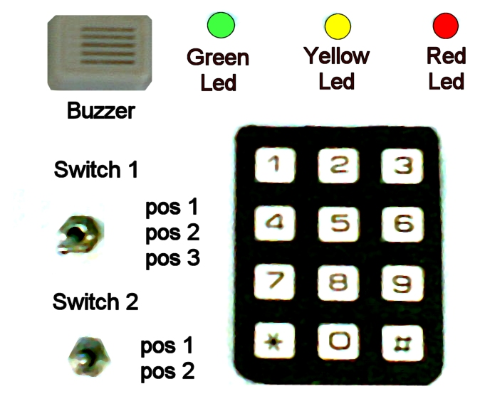

The solution for this automation problem must be based on the languages described on the IEC-61131-3 standard, i.e. ladder diagrams, instruction list and structured text.

2008-2010 original guide by Prof. Paulo J. Oliveira, 2011-2012 rev. by Prof. José Gaspar

