 | Industrial Processes Automation  MSc in Electrical and Computer Engineering  Scientific Area of Systems, Decision, and Control  Winter Semester 2011/2012

1st Laboratory Assignment

Alarm System for Intrusion Detection

This work aims the implementation of an intrusion detection alarm system, in a restricted space as a retail store having one single small room. The intrusion will be detected resorting to an infrared sensor, installed in such a way that points towards the main entrance of the space to be protected. A switch is also installed on a window of the aforementioned space.
The automation system that constitutes the alarm is to be implemented in the Schneider PLCs available on the laboratory, model Premium TSX P57 1634M or TSX P57 2634M. This document is composed by two parts: the first describes the guidelines for the first session on the lab and the second (see annex) describes the functional specifications of all the work that will be developed in the next weeks.

Part C

In the third and last part of this laboratory assignment sequences of keys must be validated, resorting to the subroutine implemented in the previous part of this work. The command console has a keyboard with 12 different keys, as detailed in the annex, which is the primary interaction device with the alarm system under design.
Please develop, implement, and test one or more sections in GRAFCET / Sequential Function Chart that, according with the interaction with the user, validates sequences of keys to activate the alarm, to change the code, restart the code to factory settings, as well as other specifications in the annex. Please write the receptivity functions in Ladder, Instruction List, or Structured Text.

Q1. Describe the general methodology to be used to validate sequences of keys of a pre-specified length. Discuss how to proceed if a key input fails.

Q2. Identify the auxiliary variables (memory) where the sequence information is stored, and the timers used for implementing the sequence read procedure:

Memory or timer  (chosen variable name) | PLC physical  address (if specified) | Short description  of the memory or timer

Q4. Write a sequence validation example, in GRAFCET.

Q5. Design the implemented receptivity sections.

Q6. Upload the program to the PLC, execute it and comment the results.

Q7. Discuss possible future improvements to the alarm system.

Annex - Functional Specifications of the Alarm

The Alarm has free main modes of operation, OFF, Presence Detector and Active. The three modes are selected by a three positions switch. The three modes operate as detailed next:
(Mode 1) OFF – this mode deactivates the alarm completely.
(Mode 2) PRESENCE DETECTOR – the infrared sensor is used to detect the movement on the room/space, that be signalized resorting both to a lamp and to the buzzer on the panel. The lamp should be on for 5 seconds, upon the detection of each person, and an acoustic signal with the duration of 1 second should be emitted.
(Mode 3) ACTIVE – in this mode the alarm is to be used.

Detailed specifications for mode 3, ACTIVE, are the following:
a) When requested for activation, a period of 30 seconds of inactivity is set to allow the user to abandon the space, and afterwards remains permanently activated.
b) Upon intrusion detection, by the infrared sensor or the window switch, the alarm evolves to the warning phase.
c) The alarm lights a warning on the panel and after 5 seconds the buzzer must be activated. The warning must be a periodic signal with 1 second on and 2 seconds off.
d) The alarm can be deactivated pressing the # key on the command panel.

Advanced Characteristics of the Alarm:

An advanced alternative for the alarm activation/deactivation consists on the use of a code previously set by the human owner (e.g. 9665). To implement the activation function, the following procedure must be implemented:
a) switch the alarm mode to ACTIVE.
b) introduce the activation code (e.g. 9665).
c) press #, and wait for 30 seconds to allow the user to abandon the space.
d) start the intrusion detection function, i.e. the alarm is fully operational.

To deactivate the alarm, upon intrusion detection or to allow the use of the space, the following instructions must be accomplished:
a) Introduce the secret code (the same as the activation one, e.g. 9665).
b) Press #
c) Change the alarm mode to a mode other the ACTIVE.

Special Characteristics of the Alarm:

A safer mode of operation for the intrusion detection alarm is to allow the user to change the activation/deactivation code. The code 0000 is initially used, as a factory preset. To change the code, the following operations must be done:
a) Press *, followed by the pre-programmed code.
b) Introduced the new code to be used, finished by *
In the case where a mistake occurs, press the code **** to reset the code to the factory default.

Available Material

In the laboratory there are six different working places, all with similar PLCs but different consoles. All workplaces have a PLC Schneider model P57. All of them have a power supply with 24V and/or 12V and a desktop PC, with the Unity Pro v6 development software and the PLC manuals, in PDF format.
In each workplace there will be also an alarm console with the following components:

12 buttons keyboard  12V buzzer  1 three positions switch  1 two positions switch  3 LEDs | 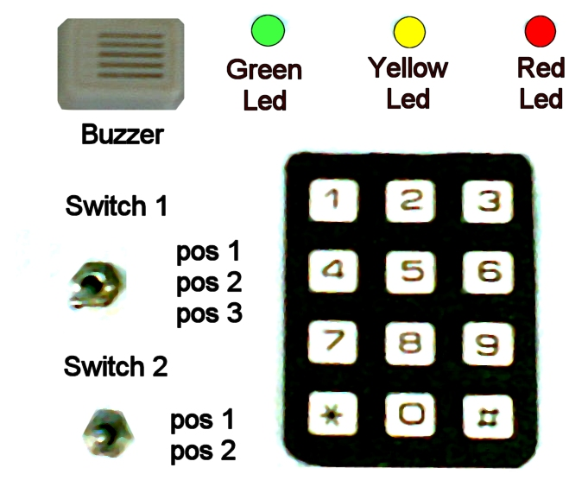

The solution for this automation problem must be based on the languages described on the IEC 1131-3 standard, i.e. ladder diagrams, instruction list and structured text.

2008-2010 original guide by Prof. Paulo J. Oliveira, 2011 rev. by Prof. José Gaspar

